**DS Assignment - 1**

GURLEEN KAUR

1024030378

Question 1

#include<iostream>

using namespace std;

int n = 5;

int max = 50;

int arr[50] = {1,2,3,4,5};

void create(){

for(int i=0;i<n;i++){

cin>>arr[i];

}

}

void display(){

for(int i=0;i<n;i++){

cout<<arr[i]<<" ";

}

cout<<endl;

}

void insertElement(){

int val,pos;

cin>>val;

cin>>pos;

if(pos<0 || pos>n){

cout<<"Invalid";

return;

}

n++;

for(int i=n-1;i>=pos;i--){

if(i>pos){

arr[i]=arr[i-1];

}

else if(i==pos){

arr[i]=val;

}

}

}

void deleteElement(){

int pos;

cin>>pos;

if(pos<0 || pos>=n){

cout<<"Invalid";

return;

}

for(int i=pos;i<n-1;i++){

arr[i]=arr[i+1];

}

n--;

}

void linearSearch(){

int val;

cin>>val;

for(int i=0;i<n;i++){

if(arr[i]==val){

cout<<i;

}

}

}

int main(){

int choice;

while(true){

cout << "\n--- MENU ---\n";

cout << "Enter your choice: ";

cin >> choice;

switch(choice){

case 1: create(); break;

case 2: display(); break;

case 3: {insertElement();

display();

break;}

case 4: {

deleteElement();

display();

break;}

case 5: linearSearch(); break;

case 6:

cout << "Exiting program..."<<endl;

return 0;

default:

cout << "Invalid choice!";

break;

}

}

}

Output:

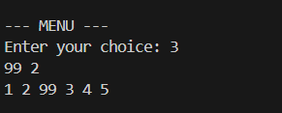

Question 2:

#include <iostream>

using namespace std;

int removeDuplicates(int arr[], int n) {

for (int i=0;i<n;i++){

for (int j=i+1;j<n;j++) {

if (arr[i] == arr[j]) {

for (int k=j;k<n-1;k++) {

arr[k] = arr[k + 1];

}

n--;

j--;

}

}

}

return n;

}

int main() {

int arr[50], n;

cout << "Enter number of elements: ";

cin >> n;

cout << "Enter elements: ";

for (int i = 0; i < n; i++){

cin >> arr[i];

}

n = removeDuplicates(arr, n);

cout << "Array after removing duplicates: ";

for (int i = 0; i < n; i++)

cout << arr[i] << " ";

cout << endl;

}

Output:

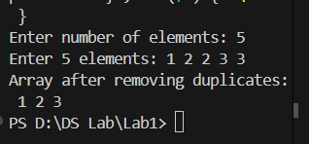

Question 3:

#include<iostream>

using namespace std;

int main()

{

int i;

int arr[5] = {1};

for (i = 0; i < 5; i++)

cout<<arr[i];

return 0;

}

Output:

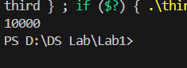

Question 4:

(a)

#include <iostream>

using namespace std;

void reverseArray(int arr[], int n) {

for (int i = 0; i < n / 2; i++) {

int temp = arr[i];

arr[i] = arr[n - i - 1];

arr[n - i - 1] = temp;

}

}

int main() {

int arr[] = {45, 78, 36, 95, 41};

int n = sizeof(arr) / sizeof(arr[0]);

reverseArray(arr, n);

cout << "Reversed array: ";

for (int i = 0; i < n; i++) cout << arr[i] << " ";

cout << endl;

}

Output:

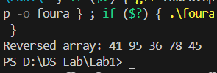

(b)

#include <iostream>

using namespace std;

int main() {

int r1, c1, r2, c2;

cout << "Enter rows and cols of first matrix: ";

cin >> r1 >> c1;

cout << "Enter rows and cols of second matrix: ";

cin >> r2 >> c2;

if (c1 != r2) {

cout << "Matrix multiplication not possible\n";

return 0;

}

int A[50][50], B[50][50], C[50][50] = {0};

cout << "Enter first matrix:\n";

for (int i = 0; i < r1; i++)

for (int j = 0; j < c1; j++)

cin >> A[i][j];

cout << "Enter second matrix:\n";

for (int i = 0; i < r2; i++)

for (int j = 0; j < c2; j++)

cin >> B[i][j];

for (int i = 0; i < r1; i++) {

for (int j = 0; j < c2; j++) {

for (int k = 0; k < c1; k++) {

C[i][j] += A[i][k] * B[k][j];

}

}

}

cout << "Result matrix:\n";

for (int i = 0; i < r1; i++) {

for (int j = 0; j < c2; j++) {

cout << C[i][j] << " ";

}

cout << endl;

}

}

Output:

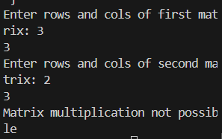

©

#include <iostream>

using namespace std;

int main() {

int r, c;

cout << "Enter rows and cols of matrix: ";

cin >> r >> c;

int A[50][50], T[50][50];

cout << "Enter matrix:\n";

for (int i = 0; i < r; i++)

for (int j = 0; j < c; j++)

cin >> A[i][j];

// Transpose

for (int i = 0; i < r; i++)

for (int j = 0; j < c; j++)

T[j][i] = A[i][j];

cout << "Transpose matrix:\n";

for (int i = 0; i < c; i++) {

for (int j = 0; j < r; j++) {

cout << T[i][j] << " ";

}

cout << endl;

}

}

Output:

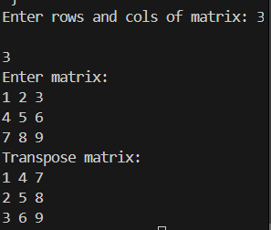

Question 5:

#include<iostream>

using namespace std;

int main() {

int r, c;

cout << "Enter number of rows and columns: ";

cin >> r >> c;

int arr[50][50];

cout << "Enter matrix elements:\n";

for (int i = 0; i < r; i++) {

for (int j = 0; j < c; j++) {

cin >> arr[i][j];

}

}

cout << "\nSum of each row:\n";

for (int i = 0; i < r; i++) {

int rowSum = 0;

for (int j = 0; j < c; j++) {

rowSum += arr[i][j];

}

cout << "Row " << i + 1 << ": " << rowSum << endl;

}

cout << "\nSum of each column:\n";

for (int j = 0; j < c; j++) {

int colSum = 0;

for (int i = 0; i < r; i++) {

colSum += arr[i][j];

}

cout << "Column " << j + 1 << ": " << colSum << endl;

}

return 0;

}

Output:

